**Christine’s** model (based on review of ENSE 374 student work, P-drive analysis, and expert opinion)

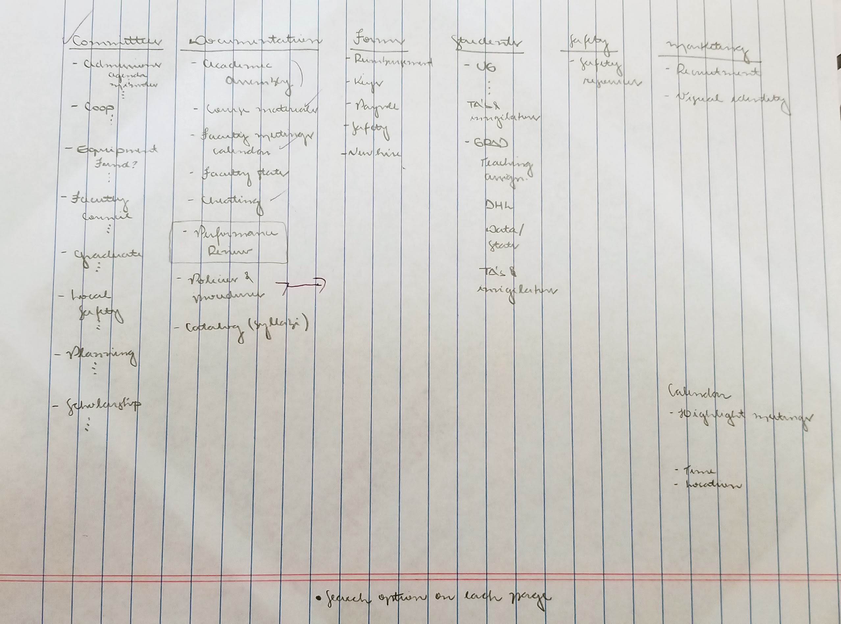

ENSE 374 SnowBird group

**Tim** particularly liked the simple content model (Committees | Course Material | Research Areas | Forms & Docs)

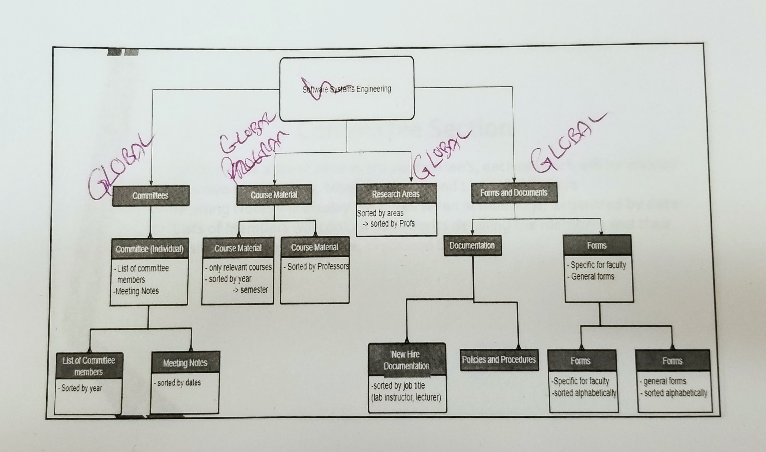

ENSE 374 project Boiled Frogs

Tim particularly liked the education and training section

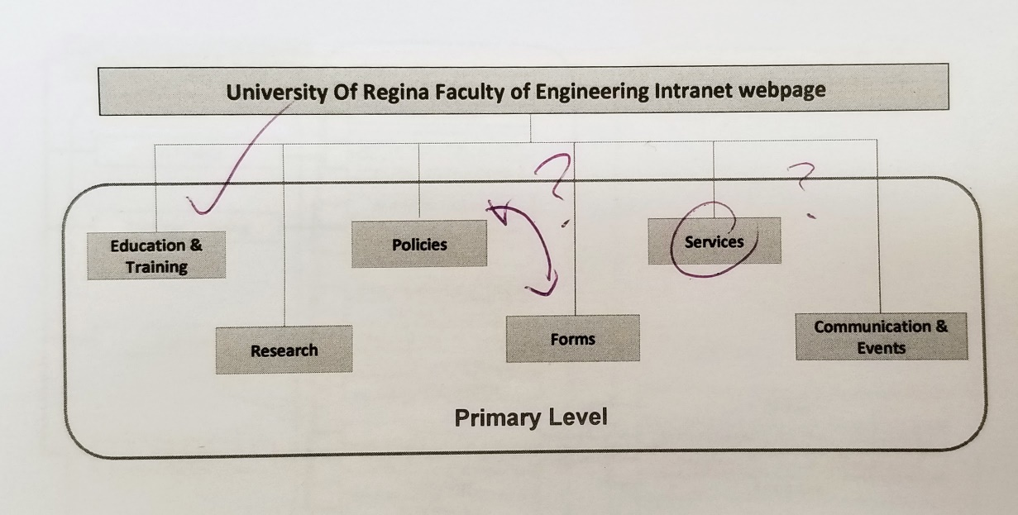

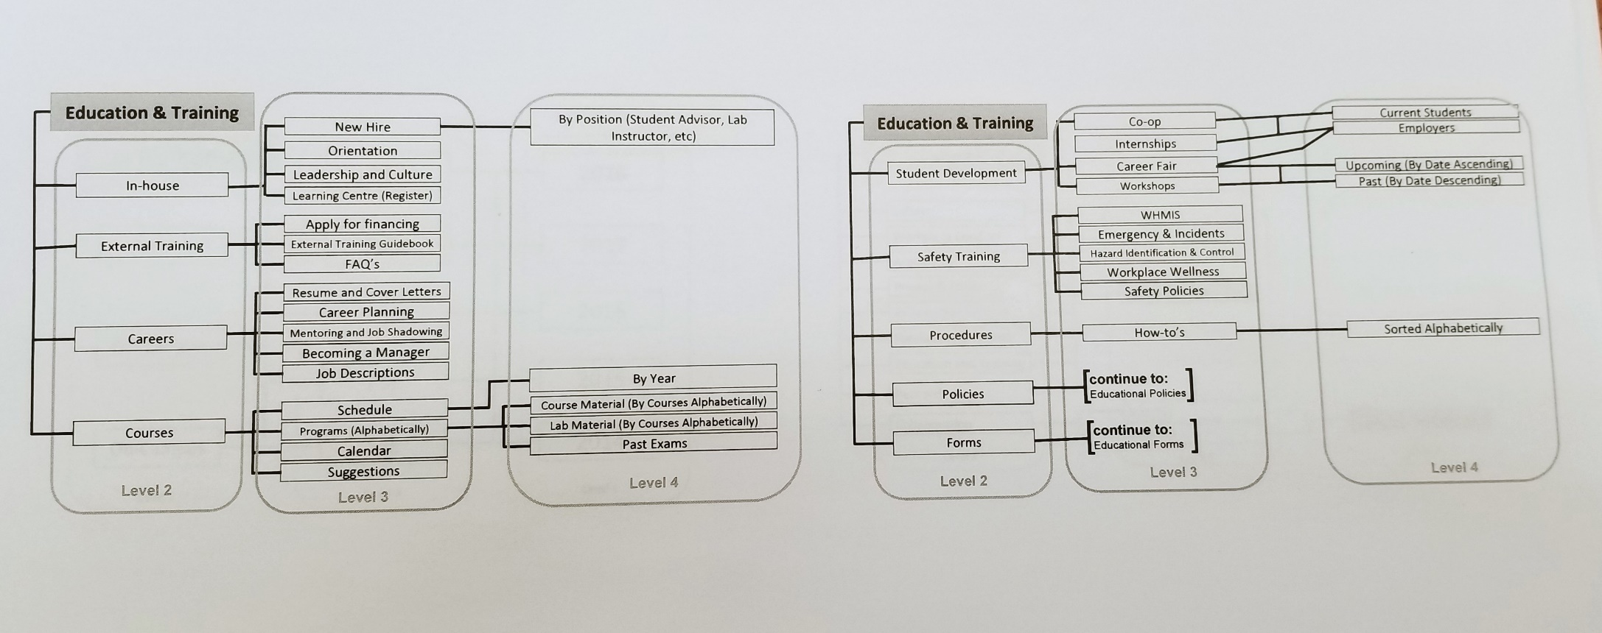

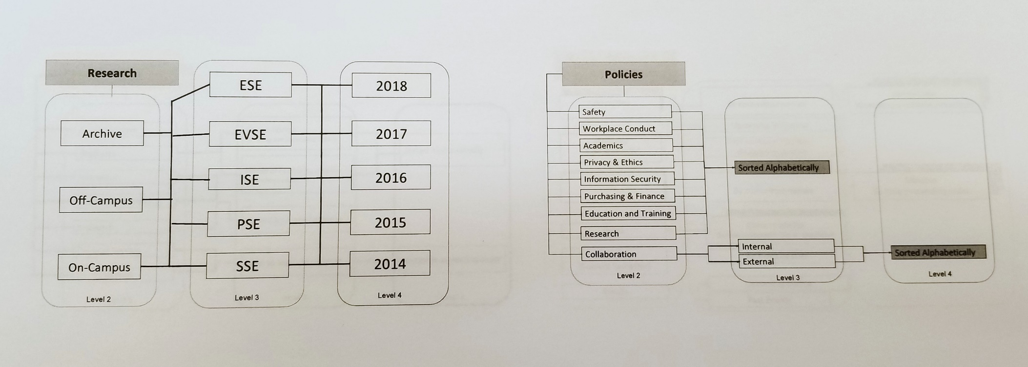

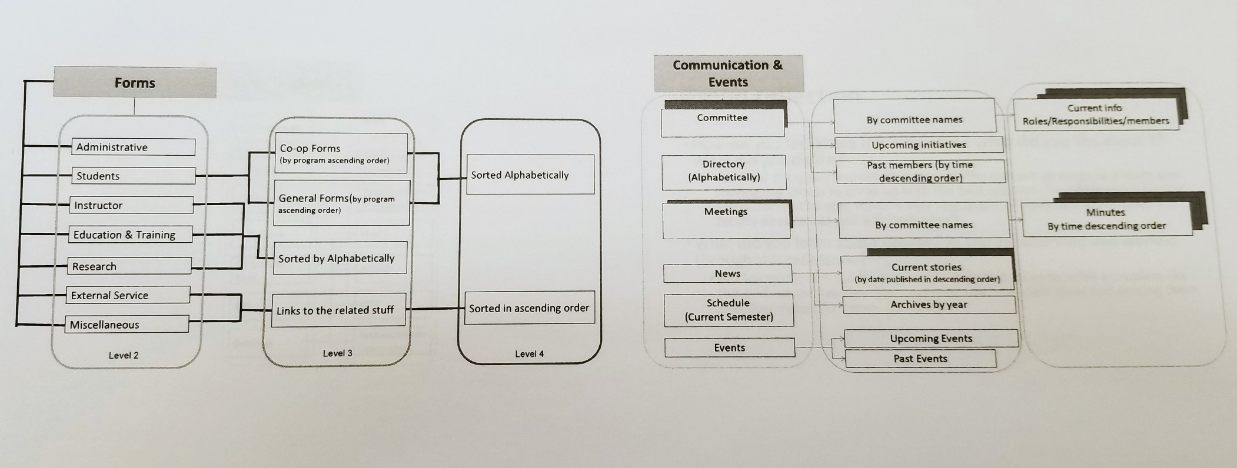

Maybe these could be quick links?

